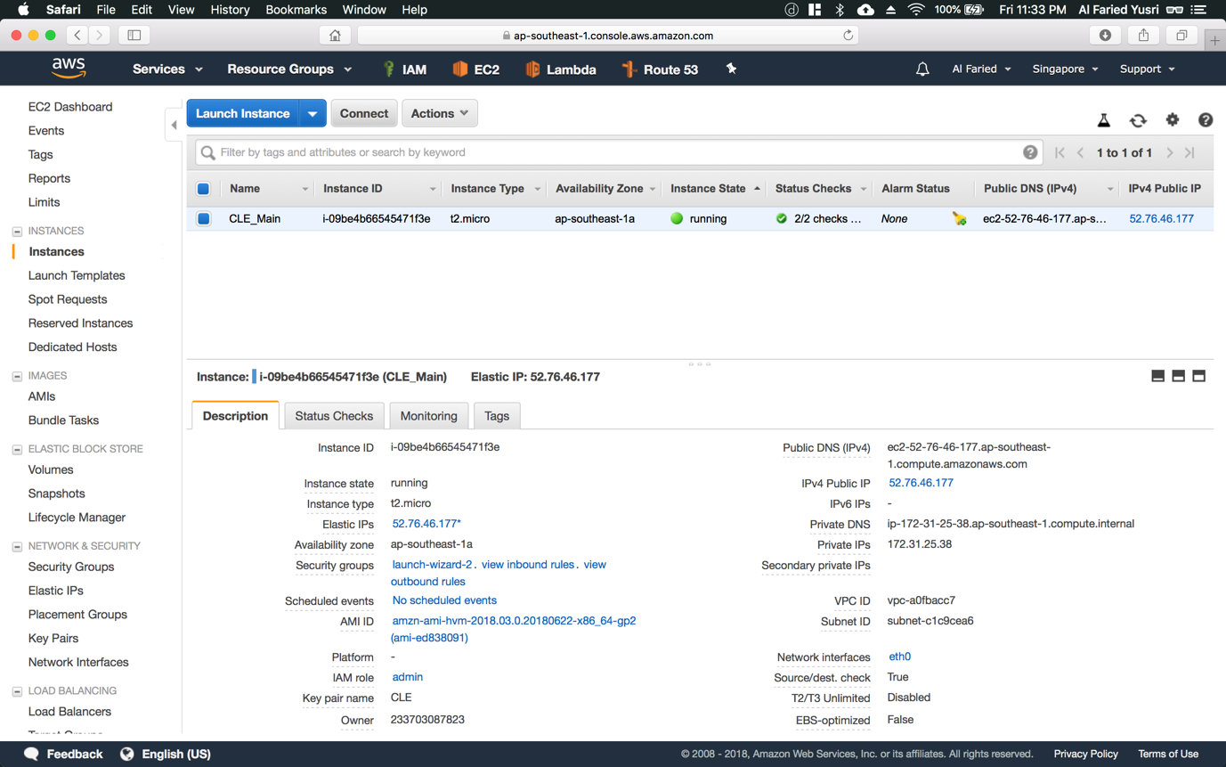

Step 1: Back on the Instances homepage, you want to select the newly launched instance and click on the “Connect” button located at the top (refer to Figure 1.1)

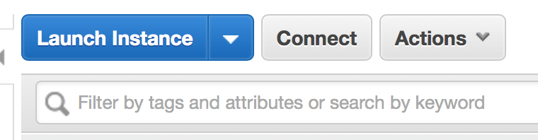

Figure 1.1

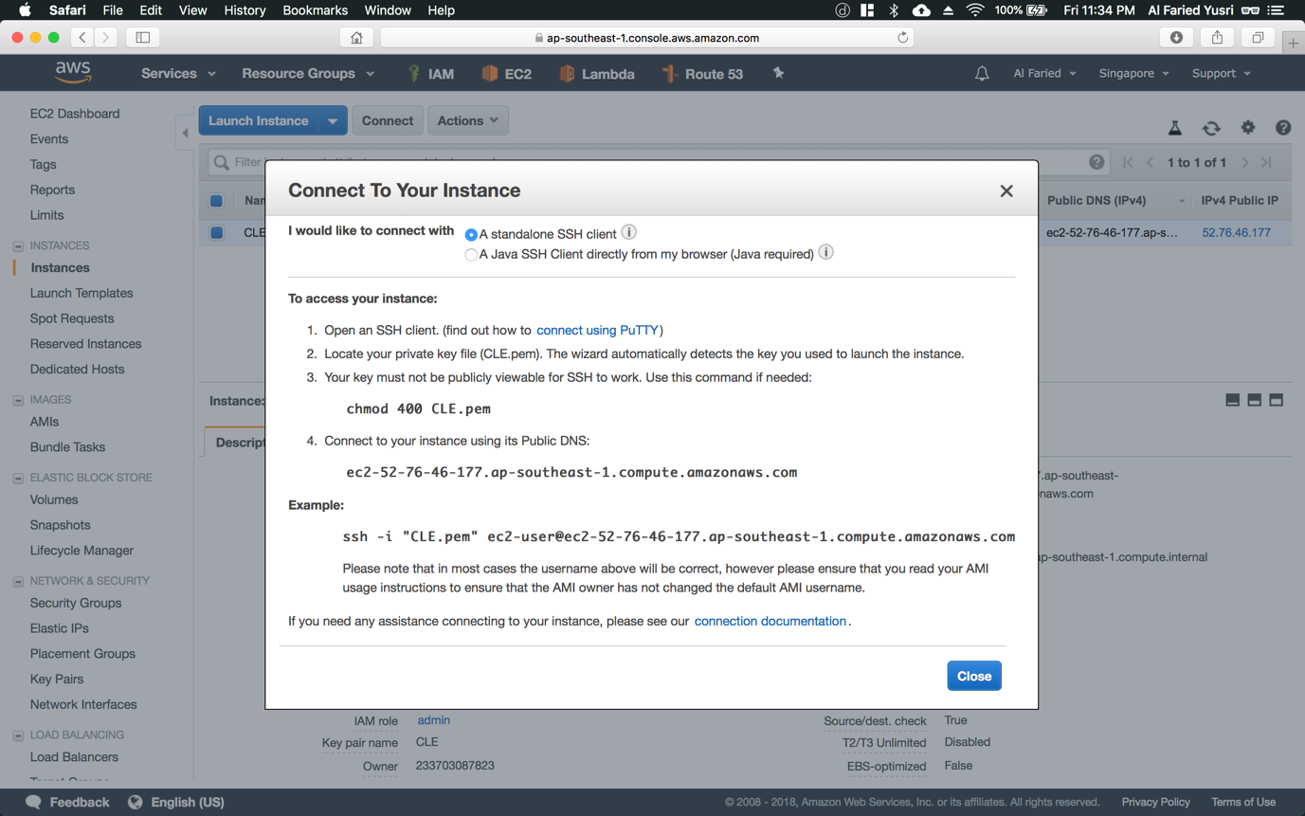

Step 2: Here, AWS will give you detailed information on how to connect to your SSH. First thing first, you would want to open up a terminal and cd into the directory where you store your key pair (.pem)

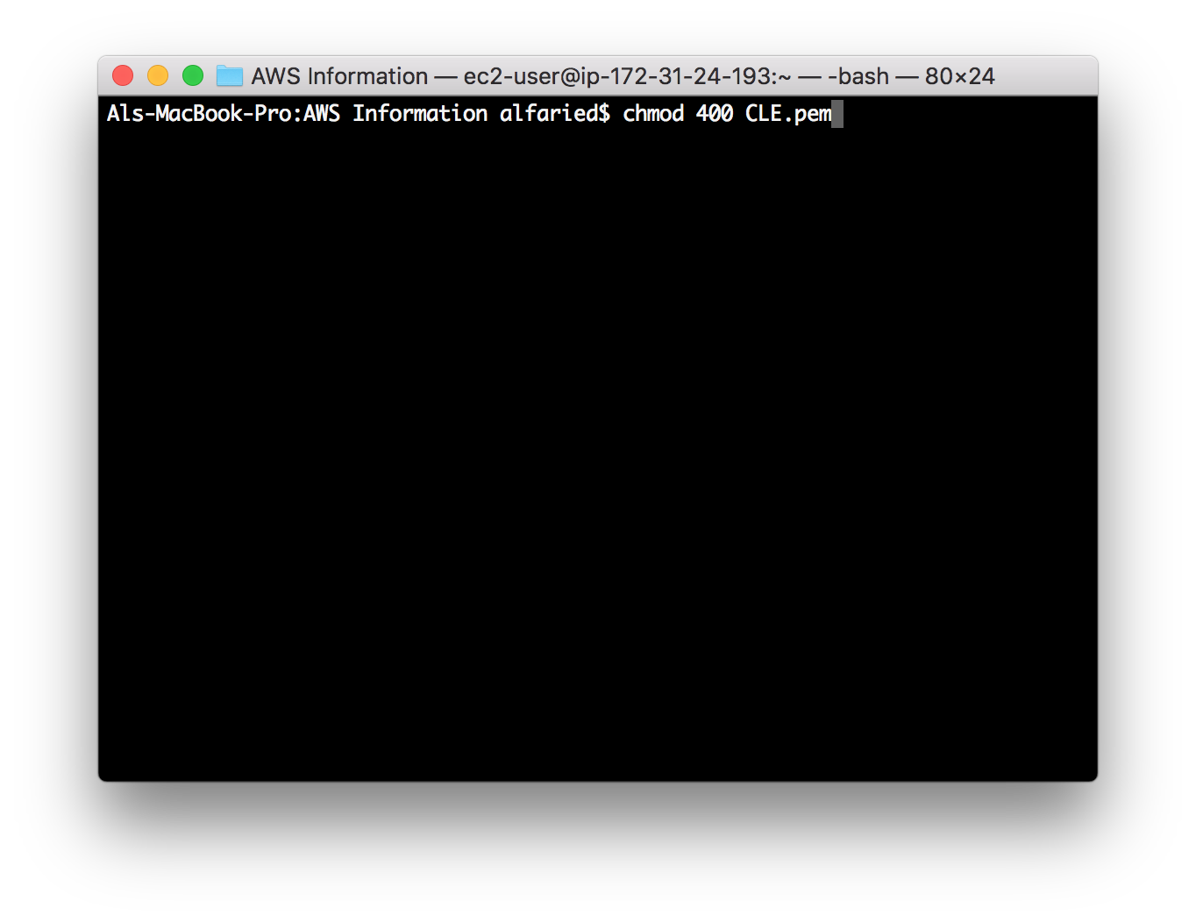

Step 3: After that, alter the read and write permission of this file by keying in command “chmod 400 <your key pair name>.pem”. Alternatively, you can just copy and paste the commands that AWS has given.

Step 4: Once you’ve done that, you can choose to connect to the server via your instance public dns or elastic ip.

**Public DNS** **-** “ssh -i <your key pair name>.pem ec2-user@<instance public dns>” (refer to Figure 2.1)

**Elastic IP -** “ssh -i <your key pair name>.pem ec2-user@<elastic ip>” (refer to Figure 2.2)

Alternatively, you can just copy and paste the commands that AWS has given.

*\*Refer to the next set of instructions after you’ve ssh into your instance*

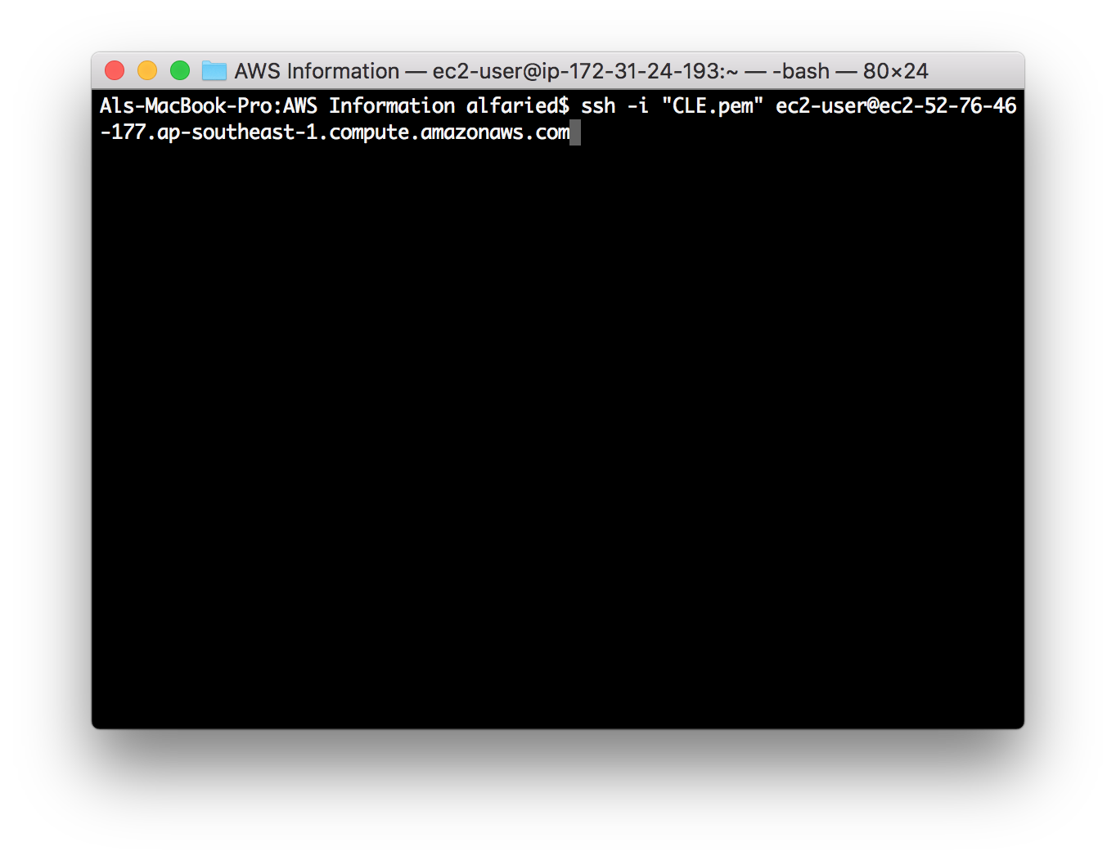

Figure 2.1

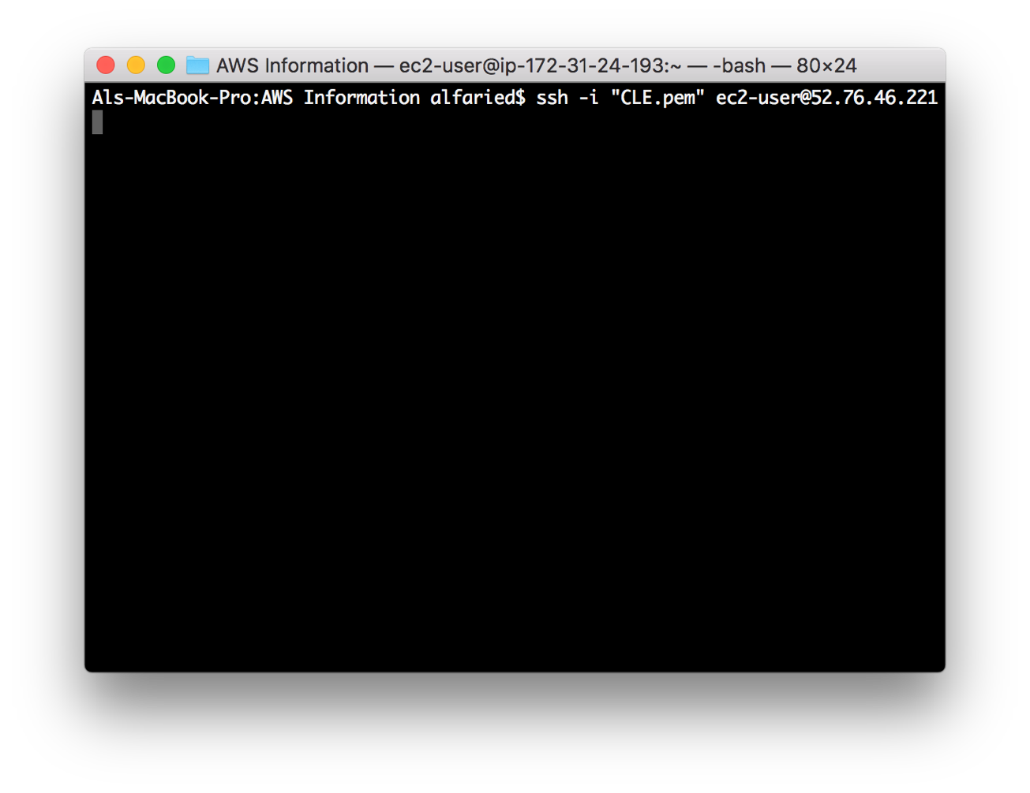

Figure 2.2